Note: CSS properties apply to all browser types unless noted by iPhone Only, or comment is highlighted in green.

AMCA login page
AMCA (IE – on IST) | AMCA-IPhone
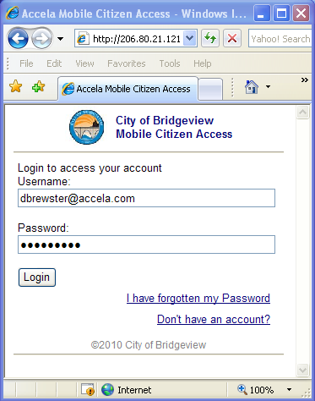  (For all pages in AMCA)  Page body body  Page Form: Form | 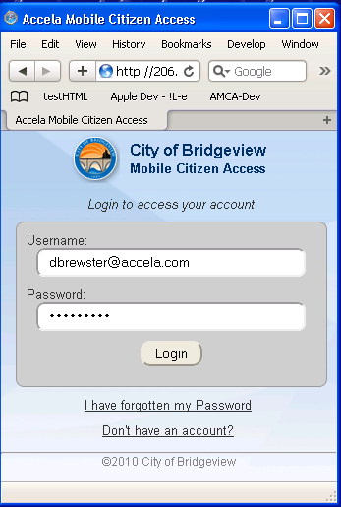  loginPageAgencyName  (all pages with logo )  pageSubmitButton &  pageSubmitButton Input  loginControlsWrapper | loginPageAppName  (all pages with logo)  loginPageGreeting  pageText  loginPageInput  loginPageLinks  pageFooter  for of all pages  pageFooter hr  for all pages

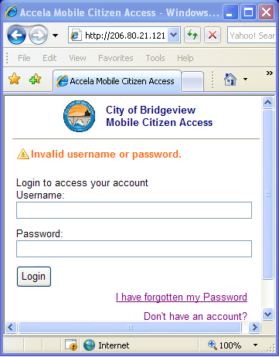 | 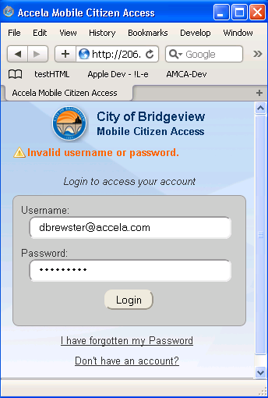 | errorMessage

AMCA login – Don’t have an account?
AMCA (IE – on IST) | AMCA-IPhone
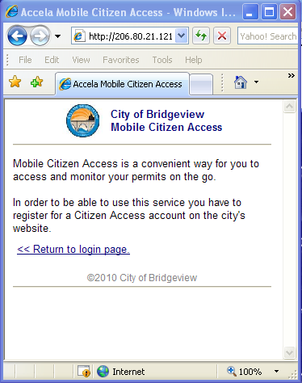  (For all pages with backward page links)  backlink  backlink a | 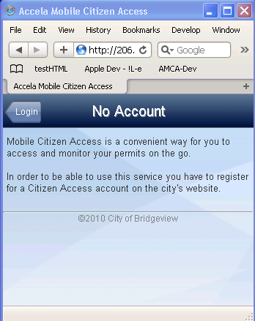 | Page sections that are not marked are the same as in previous pages  pageText  iPhoneHeaderBar  iPhoneHeaderTitle15  & iPhonePageTitle13  iPhoneBackLink  iPhoneBackLink a

AMCA login – Reset password – step 1
AMCA (IE – on IST) | AMCA-IPhone
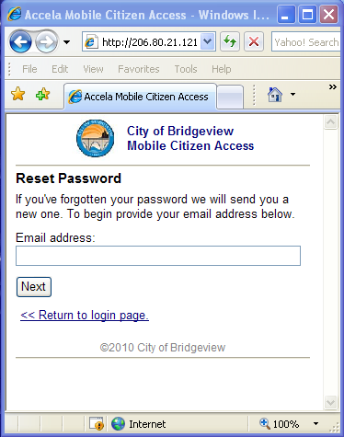  pageTitle | 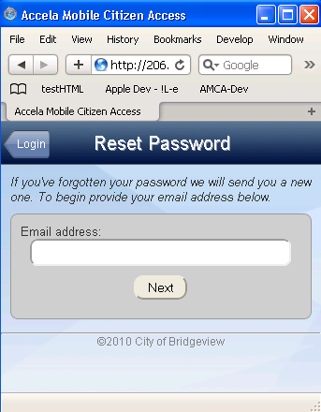 | Page sections that are not marked are the same as in previous pages.  pageSubmitButton Input  pageText

AMCA login – Reset password – step 2
AMCA (IE – on IST) | AMCA-IPhone
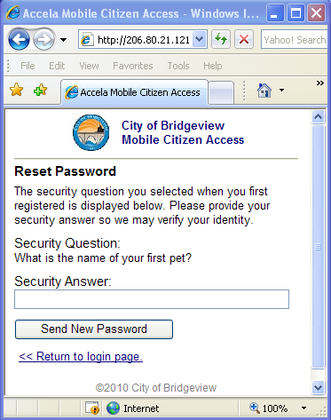  backlink  & backlinkk a | 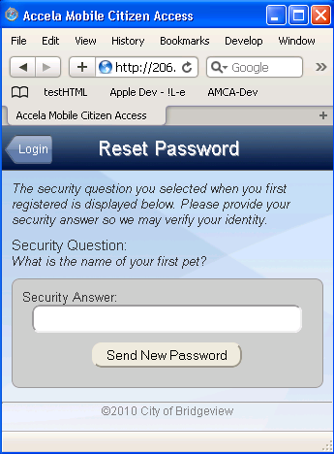  pageTextSectionName  pageText | Page sections that are not marked are the defined the same indicated in previous pages..  pageSubmitButton Input

AMCA login – Reset password – step 3
AMCA (IE – on IST) | AMCA-IPhone
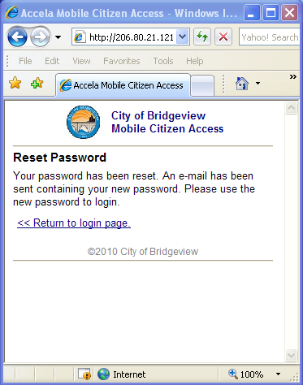 | 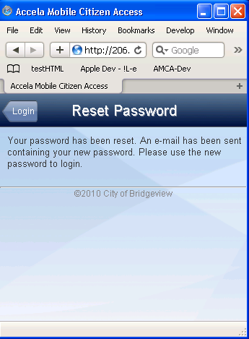 | Page sections that are not marked are the same as those marked in previous pages

AMCA Home Page
AMCA (IE – on IST) | AMCA-IPhone
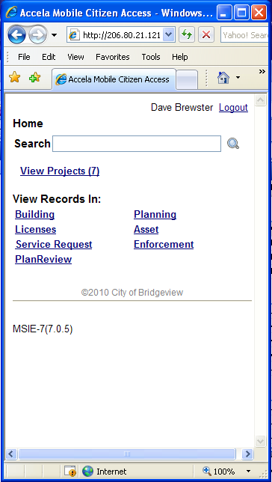  pageSectionTitle  pageListLink  iPhone, all text in cell is link.  Other Browsers, only underlined text is the link..  pageListLink  Note: if a row in the list is disabled then it is printed as plain text using:  pageListNoLink. An example would be global search that does not return parcels, the Parcels link is displayed as plain text.  pageSectionTitle  globalSearchSection  (Includes all three controls)  globalSearchSection  (Includes all three controls)  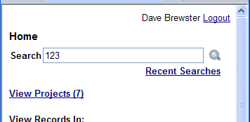  globalSearchTextInput  a  globalSearchTextInput  a  Recent Searches List:  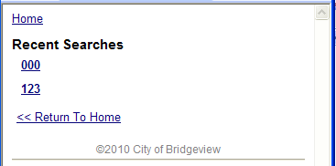 | (For all pages with bread crumbs)  breadcrumbs  breadcrumbs a  a  pageTitle  a  iPhoneCollectionLink  & iPhoneCollectionLink a  & iPhoneCollectionLink img  pageTextLink  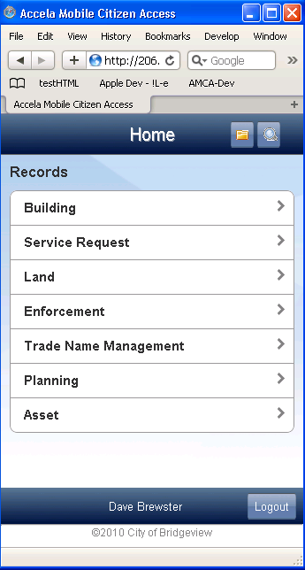  pageListTop  For home page(iPhone Only)  pageListBottom  For home page(iPhone only)  pageListMiddle  For home page(iPhone Only)  pageListCellBoldText  iPhoneGlobalSearchLink  & iPhoneGlobalSearchLink a  &iPhoneGlobalSearchLink img  iPhoneFooterBar  iPhoneFooterLogoutId  pageTextInputWrapper  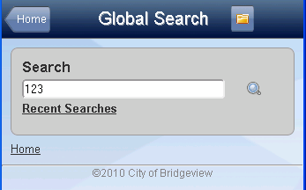  For all pages with bread crumbs)  breadcrumbs  For all pages with bread crumbs)  breadcrumbs  & breadcrumbs a  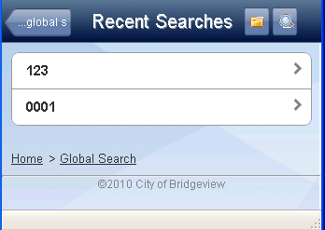 | iPhoneFooterLogoutButton

Record List(by Module)
AMCA (IE – on IST) | AMCA-IPhone
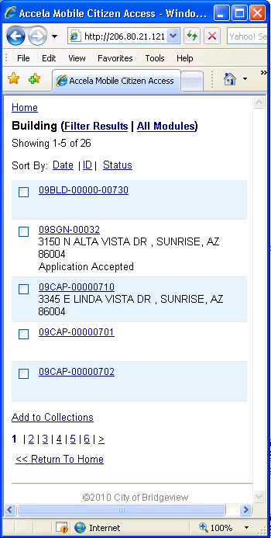  pageTitle  pageListLink  pageListLink  iPhone, all text in cell is link.  Note: if a row in the list is disabled then it is printed as plain text using:  pageListNoLink. An example would be global search that does not return parcels, the Parcels link is displayed as plain text.  sortSection  & sortSectionLink  sortSection  & sortSection input  pageText  )  pageText  )  Odd / Even Selected by row number.  pageListTopOdd  pageListTopEven  for this type of list borders are For record list - iPhone only  Odd / Even Selected by row number.  pageListMiddleOdd  pageListMiddleEven  for this type of list borders are For record list - iPhone only  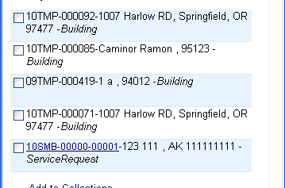  pageListNoLink  pageListNoLink  Cannot view the details of temporary or incomplete records | 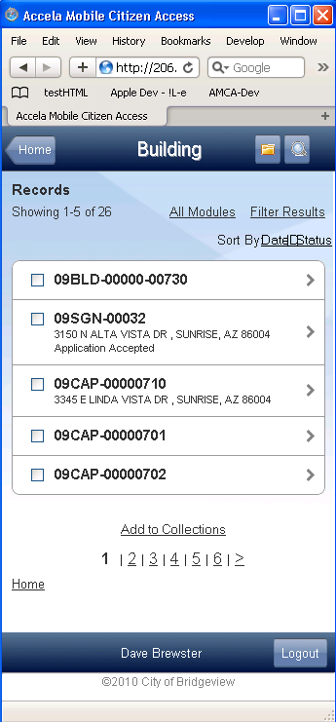  pageListCellTableLeft  Checkbox Cell (iPhone only)  pageListCellTable  Table with three columns sections: (iPhone only)  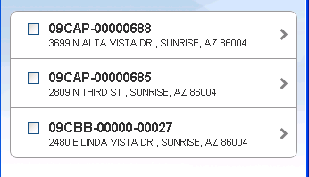  pageListCellBoldText  pageListSingleRow  for this type of list borders For record list - iPhone only  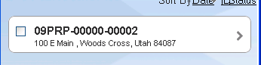  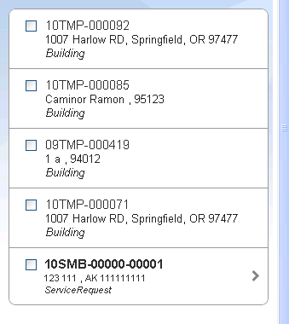 | Page sections that are not marked are the same as those marked in previous pages  pageNavigation  pageNavigationSelected  pageNavigationButton  sortSection input  )  pageTitleButton  )  Odd / Even selected by row number.  pageListBottomOdd  pageListBottomEven  for this type of list borders For record list - iPhone only  pageListCellTableRight  collectionActions  & collectionActions Input  pageListCellTableMiddle

Record List (Filter Dialog)
AMCA (IE – on IST) | AMCA-IPhone
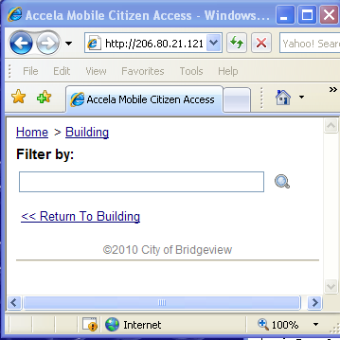 | 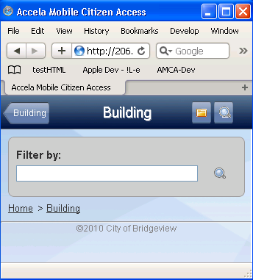 | Page sections that are not marked are the same as those marked in previous pages  pageTextInput  a  pageTitle

Record List (Collections)
AMCA (IE – on IST) | AMCA-IPhone
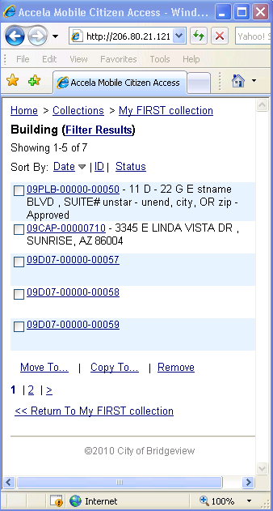  pageTitleButton  )  pageTitleButton  )  collectionsActions  collectionActions input  pageTitle  See Page 5 for list properties.  )  See Page 6 for list properties.  collectionsActions  collectionActions input | 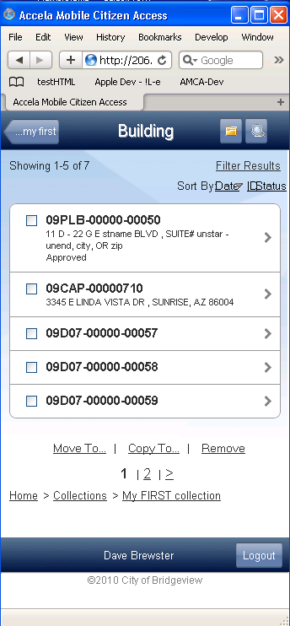 | Page sections that are not marked are the same as those marked in previous pages  See Record List (for Collections)

Global Search - Record, Parcels, Addresses, and License Professional Lists
AMCA (IE – on IST) | AMCA-IPhone
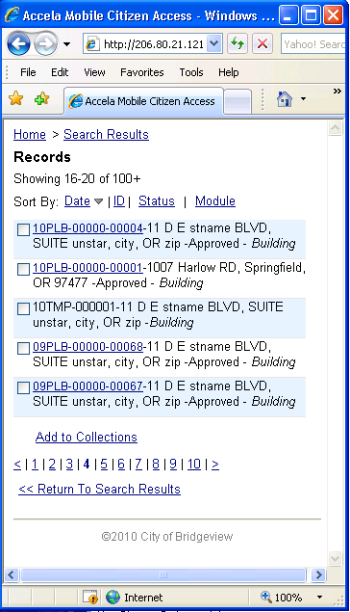  See Page 5 for list properties.  See Page 6 for list properties. | 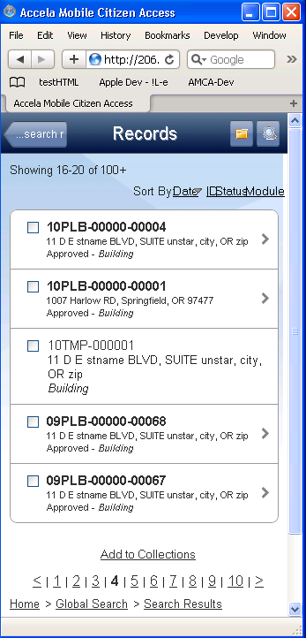 | Page sections that are not marked are the same as those marked in previous pages  See:  Recorsd List (for Collections) Records List (by Module)

Record Detail Page:
AMCA (IE – on IST)  pageTitle  Also displays for iPhone when title text clipped to fit. | AMCA-IPhone
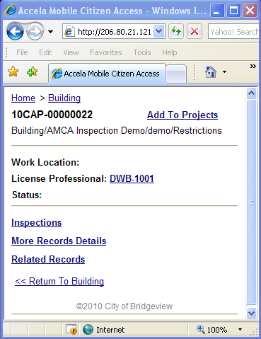  collectionActionLink  pageSectionTitle  pageTextHR  pageLineLink  pageListTop  pageListMiddle  pageListBottom  Supply magring and padding for all browser in lists of this type.  pageListTop  pageListMiddle  pageListBottom  Supply margrins, borders, and padding for all browser in lists of this type. See Page 4 for more details. | 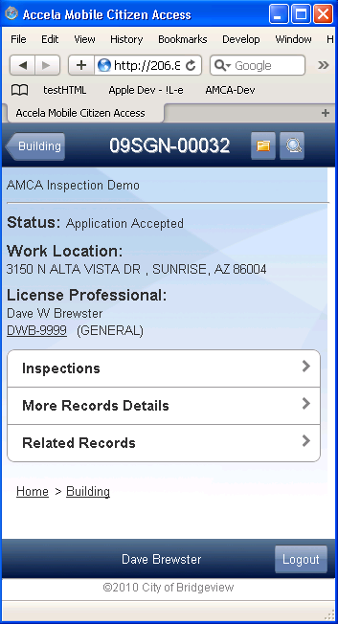  pageText  pageLineText  pageText | Page sections that are not marked are the same as those marked in previous pages

Collections List:
AMCA (IE – on IST) | AMCA-IPhone
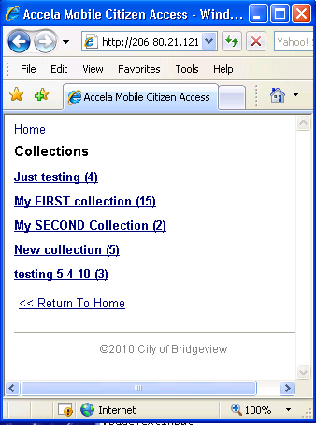  pageTitle  pageListTop  pageListMiddle  pageListBottom  Supply margrins, borders, and padding for all browser in lists of this type. See Page 4 for more details.  pageListTop  pageListMiddle  pageListBottom  Supply margrins, borders, and padding for all browser in lists of this type. See Page 4 for more details. | 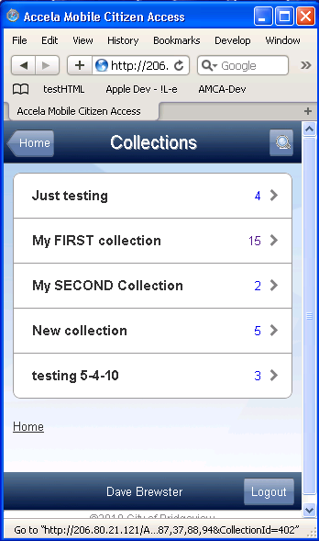 | Page sections that are not marked are the same as those marked in previous pages
Collections Summary:
AMCA (IE – on IST) | AMCA-IPhone
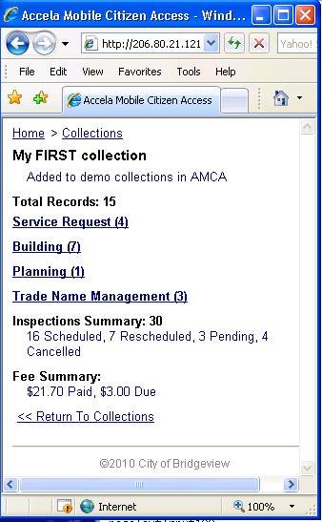  pageTitle  page title also show on iPhone page when header title is clipped to fit.  pageListTop  pageListMiddle  pageListBottom  Supply margrins, borders, and padding for all browser in lists of this type. See Page 4 for more details.  pageListTop  pageListMiddle  pageListBottom  Supply margrins, borders, and padding for all browser in lists of this type. See Page 4 for more details. | 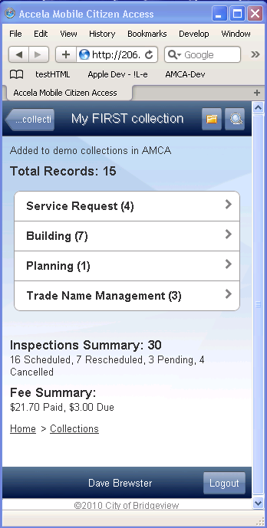 | pageTextIndented  pageTextIndented  pageTextIndented  pageSectionTitle  pageSectionTitle

Collection New/Copy/Add/Remove
AMCA (IE – on IST) | AMCA-IPhone
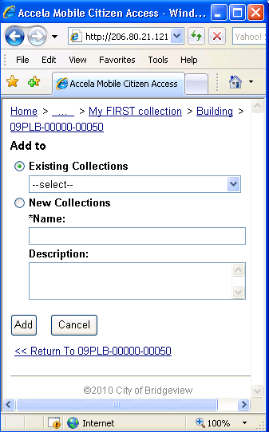  pageTextTitle  pageSectionTitle  pageSectionTitle  pageSectionTitle | 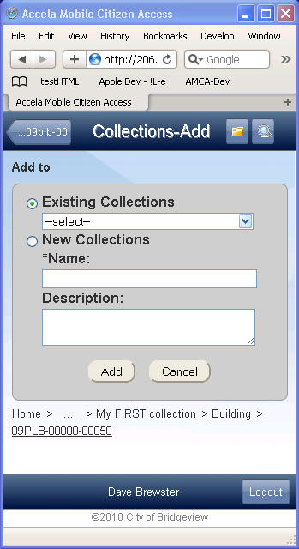  pageSubmitButton  pageSubmitButton Input | pageTitle  pageTextInput  pageTextInput  pageTextAreaInput
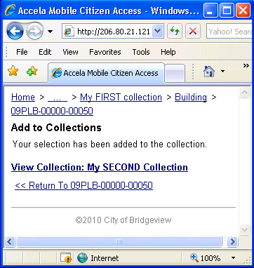 | 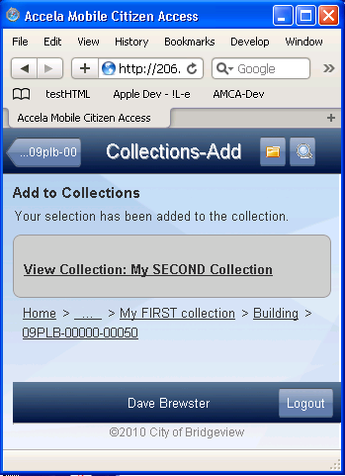 | pageTextLink  pageText

Global Search: License Professionals List:
AMCA (IE – on IST) | AMCA-IPhone
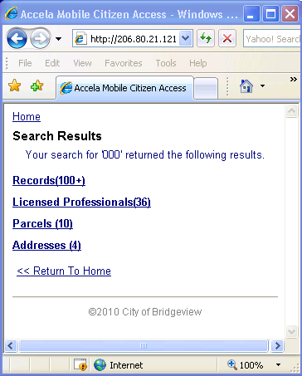  pageTitle  pageListTop  pageListMiddle  pageListBottom  Supply margrins, borders, and padding for all browser in lists of this type. See Page 4 for more details.  pageListTop  pageListMiddle  pageListBottom  Supply margrins, borders, and padding for all browser in lists of this type. See Page 4 for more details. | 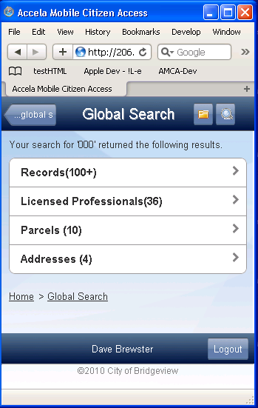 | Page sections that are not marked are the same as those marked in previous pages  pageTextIndented

Global Search: License Professionals List:
AMCA (IE – on IST) | AMCA-IPhone
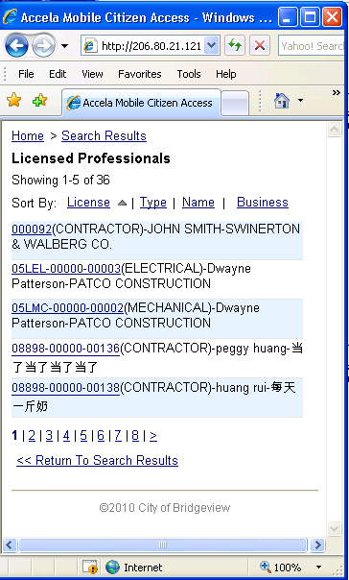  See Page 5 for list properties.  See Page 6 for list properties. | 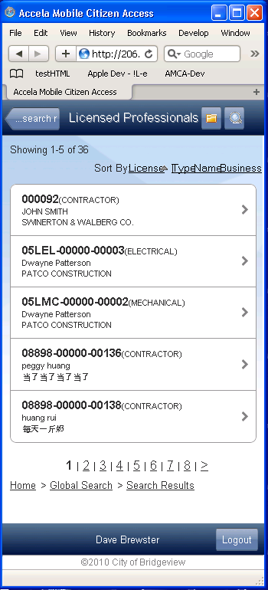 | Page sections that are not marked are the same as those marked in previous pages

Global Search: License Professional:
AMCA (IE – on IST) | AMCA-IPhone
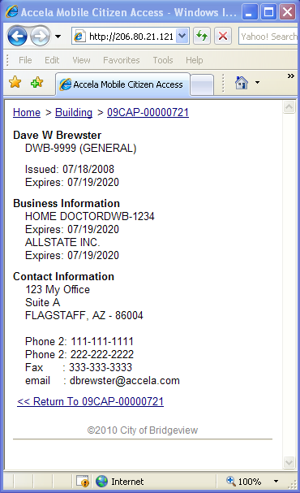 | 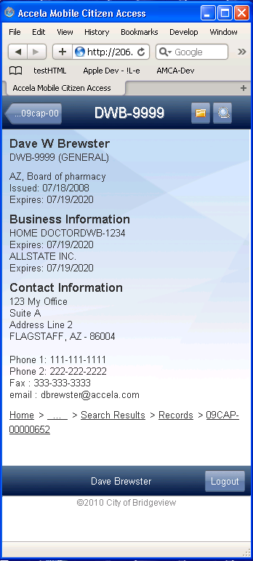 | Page sections that are not marked are the same as those marked in previous pages  pageSectionTitle  pageSectionTitle  pageSectionTitle  pageTextIndented  pageTextIndented  pageTextIndented

Global Search: Address List:
AMCA (IE – on IST) | AMCA-IPhone
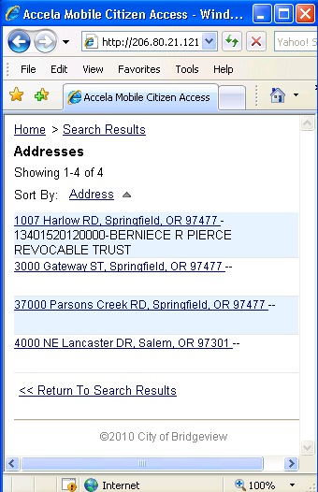  See Page 5 for list properties.  See Page 6 for list properties.  Note: for Addresses, Parcels, and License Pro’s there is no checkbox. | 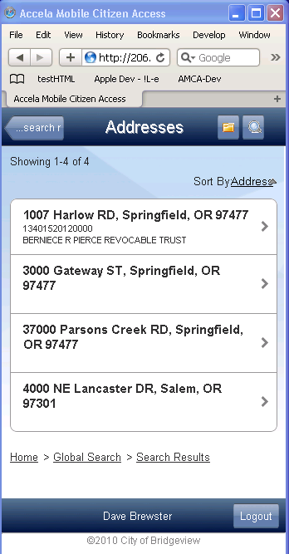 | Page sections that are not marked are the same as those marked in previous pages
Global Search: Address Detail:
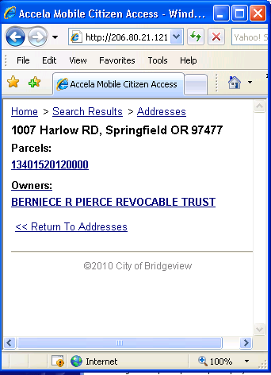  pageListTop  pageListMiddle  pageListBottom  Supply margrins, borders, and padding for all browser in lists of this type. See Page 4 for more details.  pageListTop  pageListMiddle  pageListBottom  Supply margrins, borders, and padding for all browser in lists of this type. See Page 4 for more details. | 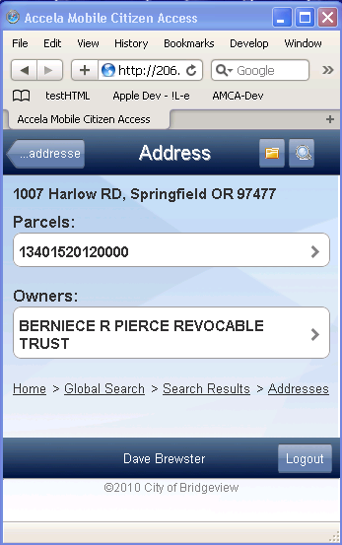 | Page sections that are not marked are the same as those marked in previous pages  pageSectionTitle  pageSectionTitle  pageTitle

Global Search: Parcels List:
AMCA (IE – on IST) | AMCA-IPhone
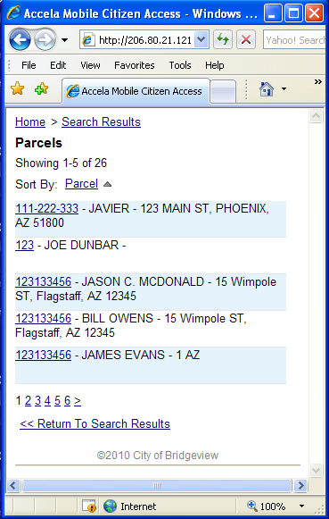  See Page 5 for list properties.  Note: for Addresses , Parcels, and License Pro’s there is no checkbox.  See Page 6 for list properties.  Note: for Addresses, Parcels, and License Pro’s there is no checkbox. | 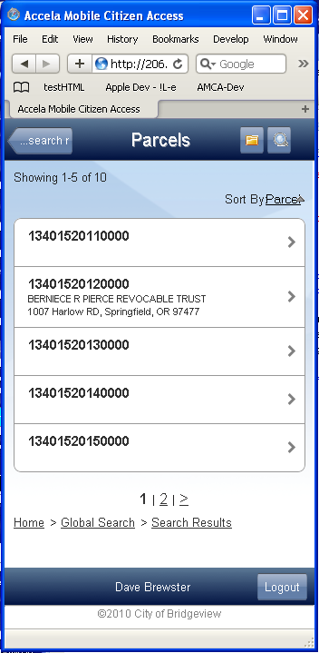 | Page sections that are not marked are the same as those marked in previous pages

Global Search: Parcel Detail:
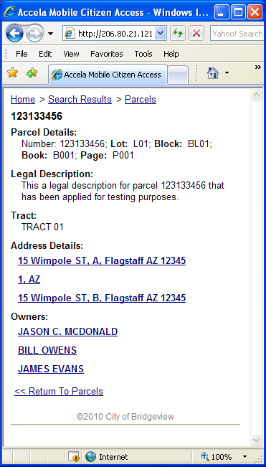  pageListTop  pageListMiddle  pageListBottom  Supply margrins, borders, and padding for all browser in lists of this type. See Page 4 for more details.  pageListTop  pageListMiddle  pageListBottom  Supply margrins, borders, and padding for all browser in lists of this type. See Page 4 for more details. | 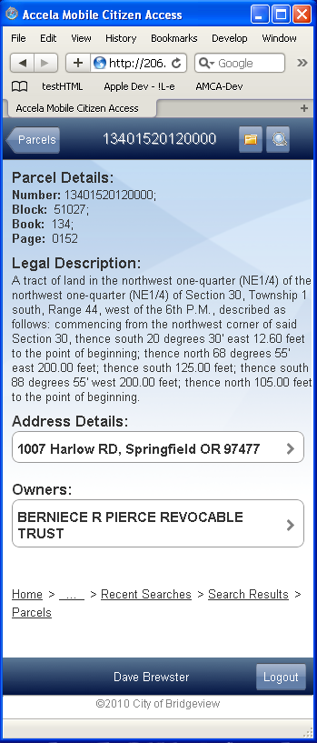 | Page sections that are not marked are the same as those marked in previous pages  pageSectionTitle  pageTextIndented  pageTitle  pageTextIndented

Inspections List:
AMCA (IE – on IST) | AMCA-IPhone
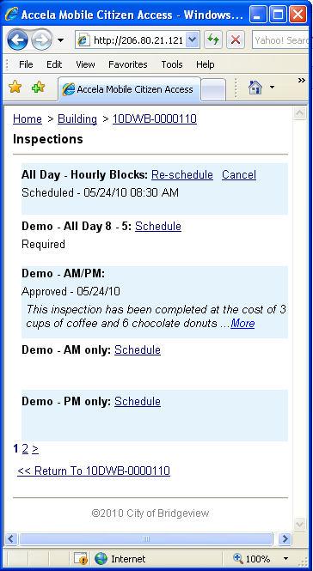  pageTitle | InspectionLineTitle  InspectionListBottom  InspecitonListBottomOdd  InspecitonListBottomEven  InspectionListTop  InspecitonListTopOdd  InspecitonListTopEven  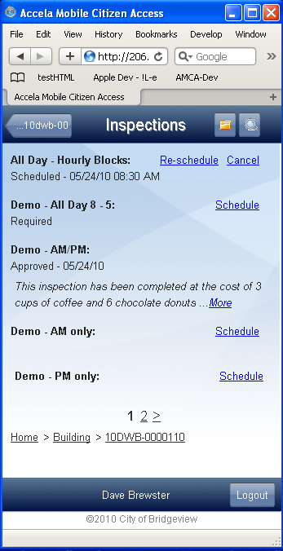  InspectionLine  Wraps all of the detail displayed for each inspection.  InspectionLineLink  InspectionLineHistory  InspectionLineComment  InspectionListMiddle  InspecitonListMiddleOdd  InspecitonListMiddleEven  InspectionLineCommentLink  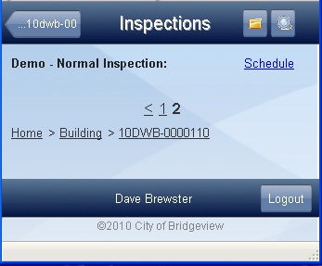  InspectionListSingleRow
Inspection Schedule/Reschedule:
AMCA (IE – on IST) | AMCA-IPhone
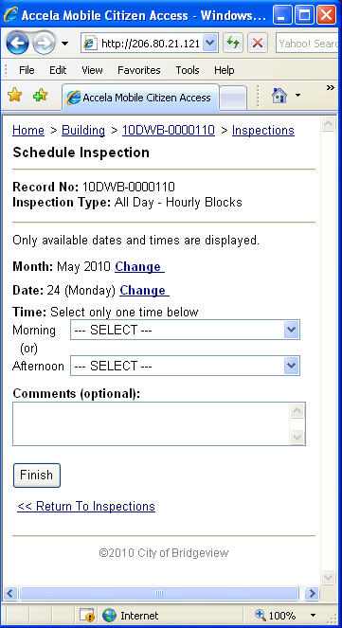  pageSectionTitle  pageSectionTitle  pageSectionTitle  pageTitle  pageTextAreaInput | 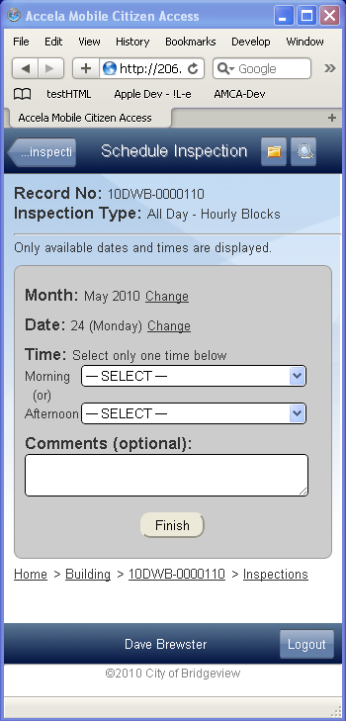  pageText  pageLineLink  pageLineLink  pageTextInput100  pageTextInput100  pageLineText  pageLineText  pageSubmitButton | Page sections that are not marked are the same as those marked in previous pages

Inspection Schedule/Reschedule/Cancel - Confirmation:
AMCA (IE – on IST) | AMCA-IPhone
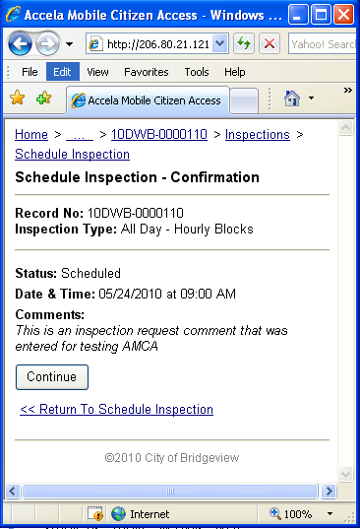 | 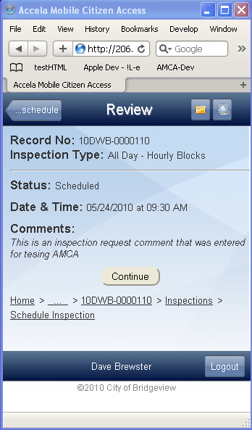  inspectionLineComment | Page sections that are not marked are the same as those marked in previous pages  See “Inspection Schedule/Reschedule” style properties.  pageSubmitButton
Inspection Cancel:
AMCA (IE – on IST) | AMCA-IPhone
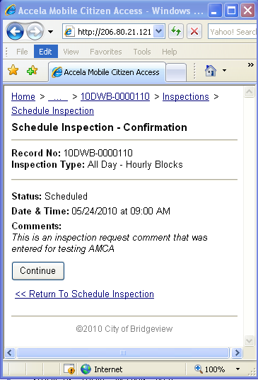 | 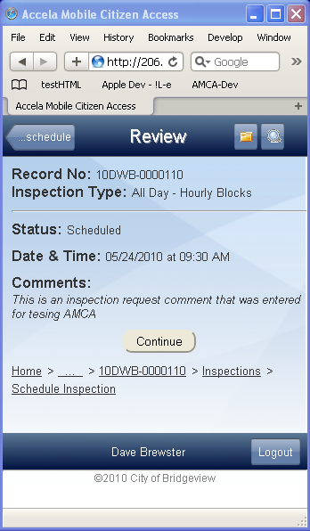 | Page sections that are not marked are the same as those marked in previous pages  See “Inspection Schedule/Reschedule” style properties.
Inspection Schedule – Successful / failed.
AMCA (IE – on IST) | AMCA-IPhone
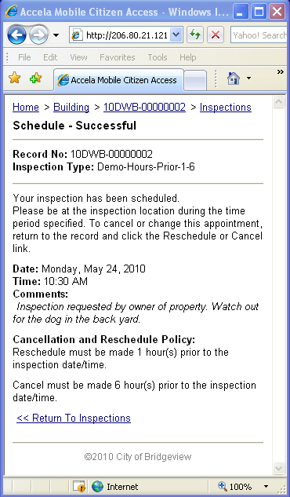 | 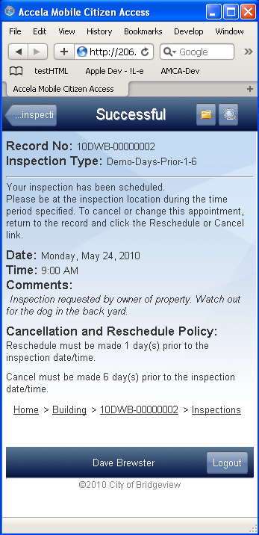 | Page sections that are not marked are the same as those marked in previous pages  pageSectionTitle  See “Inspection Schedule/Reschedule” style properties.  pageText  pageText  pageWithNoForm  This property provides the right and left margins for the page.

